**Testing Procedure**

To show that you have done the implementation of your app, you need to follow the steps below and capture a screenshot - which is to be submitted through the assignment submission part in the next unit.

Note: You may click on this [link](https://courses.edx.org/courses/course-v1:HKUSTx+COMP107x+2016_T1/jump_to_id/f730b04c646e47208799f7996f34658f) to view the video instructions again on how to carry out the automated test for your assignment.

1. After you import the pre-configured project into Android Studio and implement your solution to the assignment, please proceed to the next step.  
     
   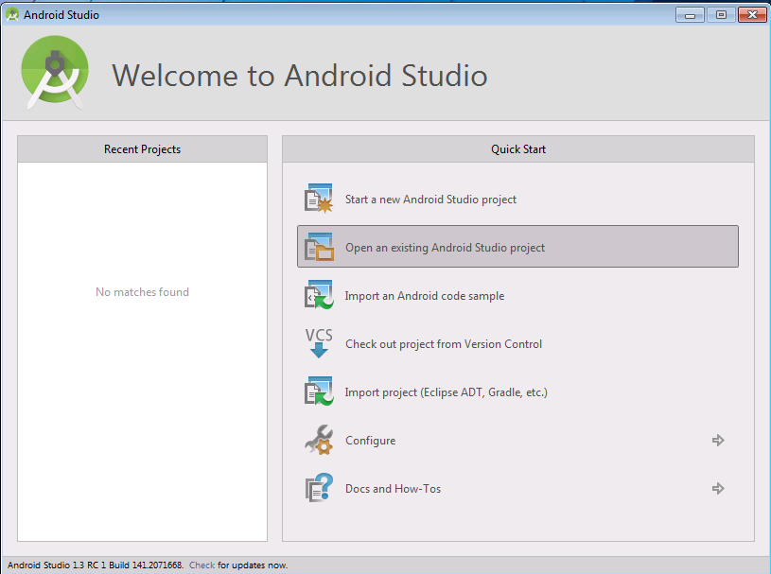
2. Conduct an automated test to make sure your code has been implemented correctly. To do that, you need to add a new Run Configuration to the project by clicking on “**app**” and then selecting “**Edit Configurations**…” as shown in the image below.  
     
   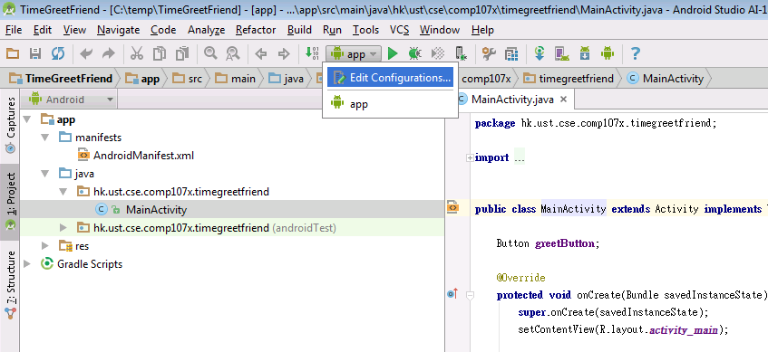
3. When the “**Run/Debug Configuration**” window starts, click on the plus sign (“+”) at the upper left corner, as shown below, to add a new configuration. Select “**Android Tests**” from the menu.  
     
   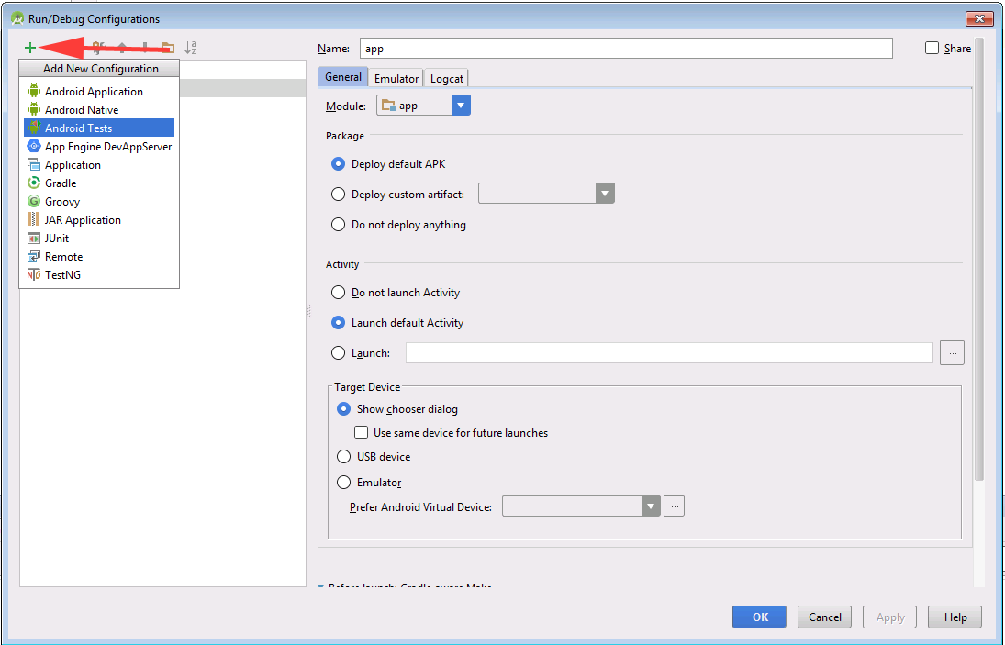
4. When the configuration window opens, type the **Name** as “*test*” and select the **Module** as “*app*”, as shown below.  
     
   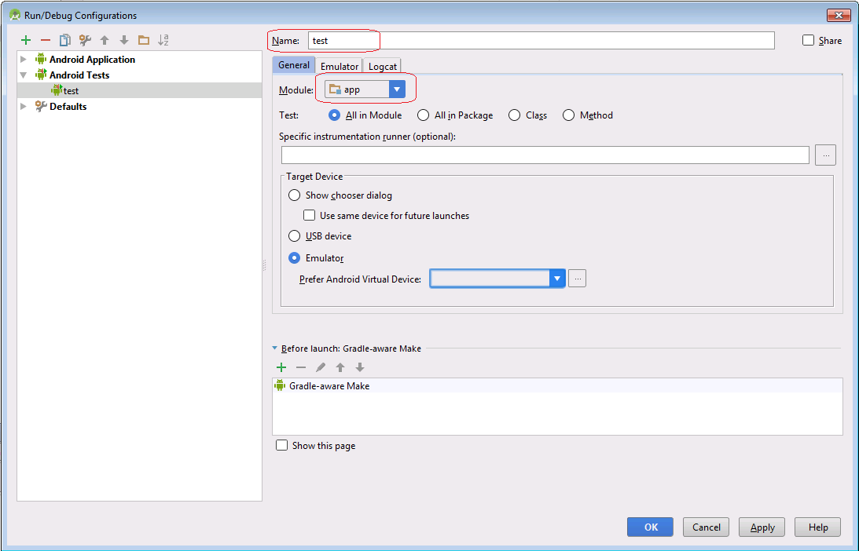
5. Click on the **Run ‘test’**icon to run the automated test. If the Android Virtual device’s screen has been locked, make sure you unlock it before running the test. Otherwise, the test could fail with complaints (e.g. unable to perform a click or can not get view focus for a period of time, etc.).  
     
   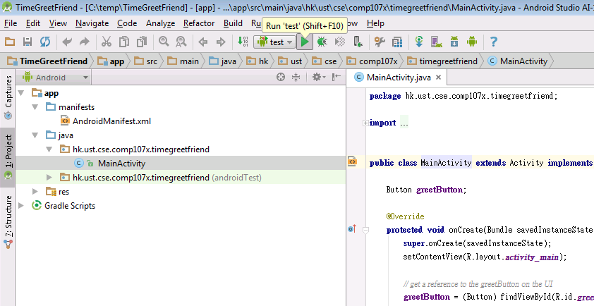
6. Upon completion, if all the tests succeeded, then you will see a screen with a green bar as shown below.  
     
   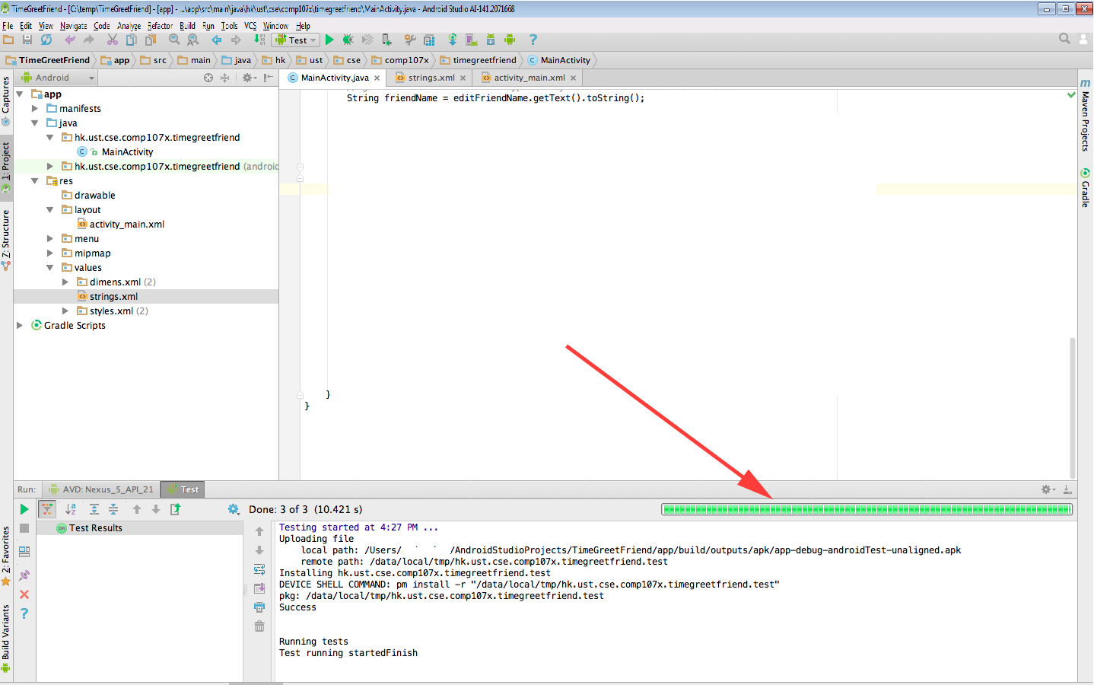
7. If some of the tests failed, then you will see a screen with a red bar as shown below.  
     
   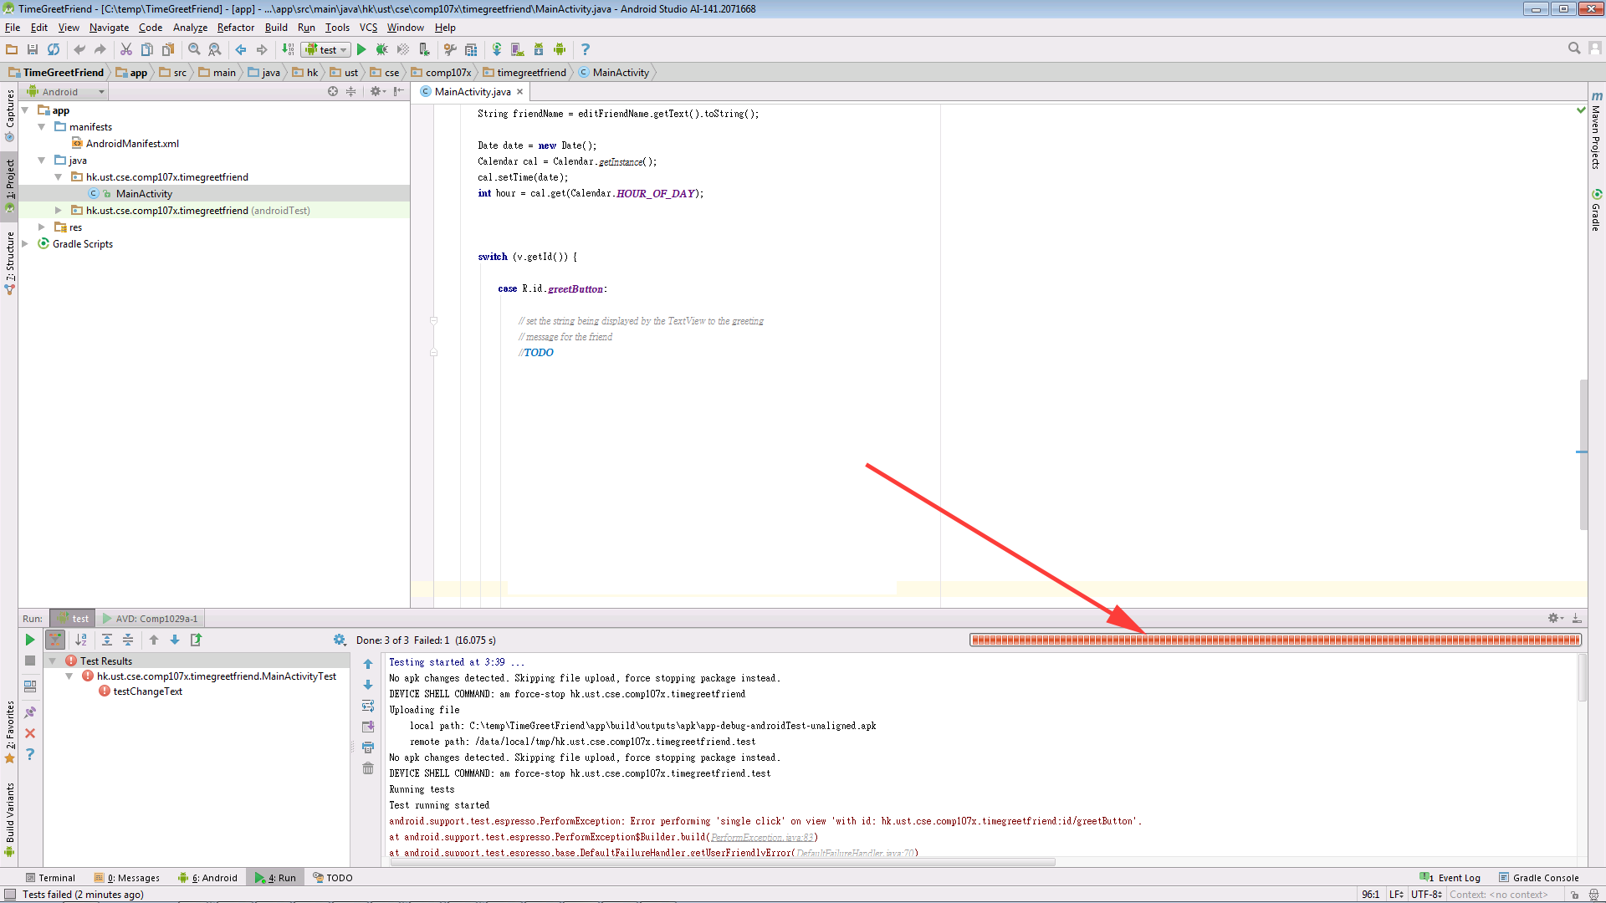
8. Capture the result of the test in a screenshot. Save the screenshot as **jpg**/**png**format, this will be the image that you will need to submit in the assignment response.   
     
   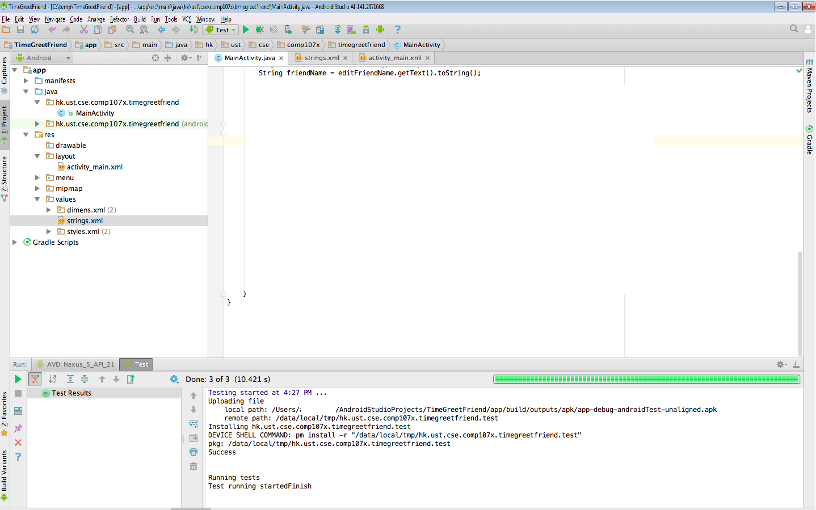

**Submission Instructions**

1. Find all the “TODOs” from the project by clicking the “**TODO**” button at the bottom of the Android Studio. Copy and paste the TODOs and the Java code that you wrote one by one on the textbox highlighted below.  
     
   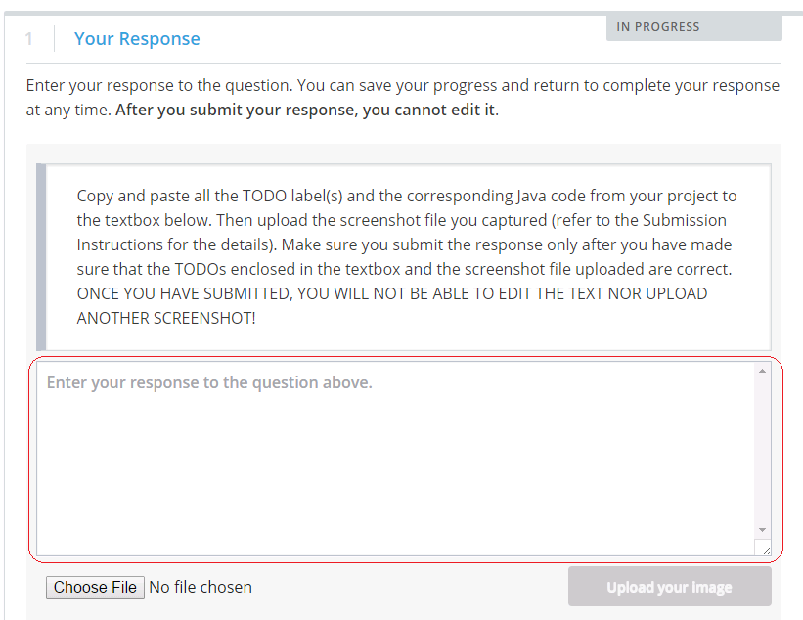
2. After you have filled out the textbox with TODO label(s) and the corresponding Java code, click on the “**Choose File**” button to attach the screenshot file you saved in the previous section. Make sure that the screenshot file size is **less than 5MB**, otherwise you will not be allowed to upload it.  
     
   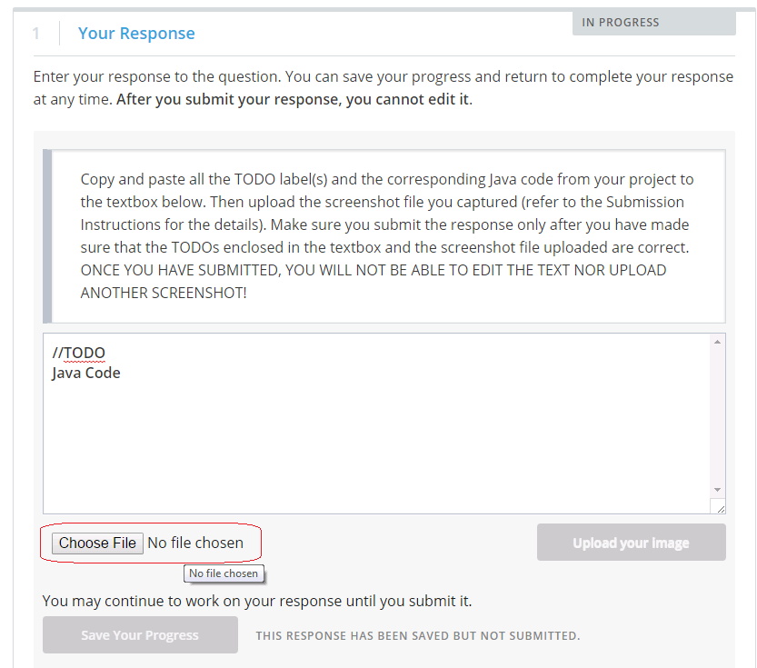
3. Now, click on the “**Upload your image**” button to attach your screenshot file. You will see a preview of your screenshot, make sure it is the correct one.  
     
   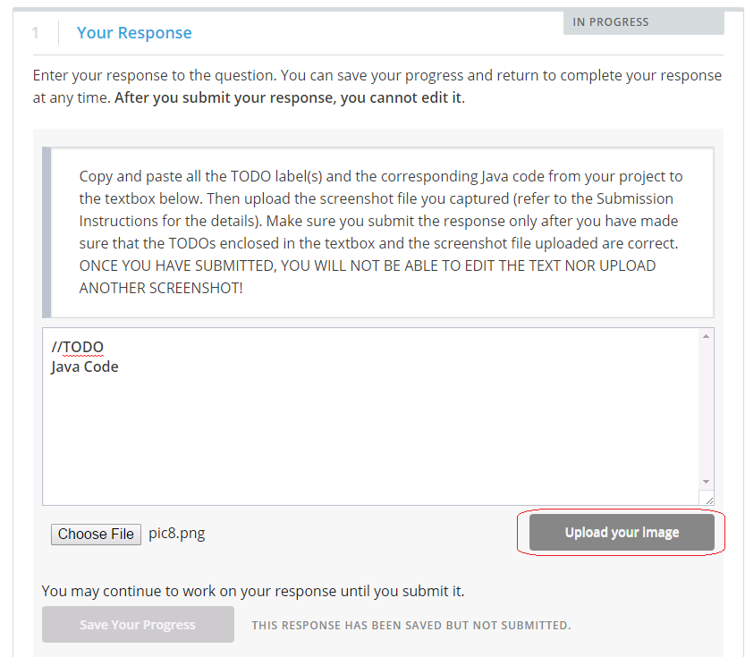
4. If you feel everything is fine, you could press the “**Submit your response and move to the next step**” button as shown below. Please make sure that you are really ready to submit before you press the button – once you have submitted, there is **no way to re-submit** even if later you discover there were something wrong with the materials you have submitted. So please be cautious before submitting.  
     
   